
Kenechukwu Tony Onuora

14252549

Data science

Project leader: Katerina Stamou

Date of submission:17th April, 2025

5004CMD Big Data Programming Project Report
Title: Investigating Human Mobility Through Scalable Data Analytics Course: Data Science (5004CMD) Date of Submission: 17/04/2025 Student Name: Kenechukwu Tony Onuora SID: 14252549

Abstract
The paper evaluates human movement through large-scale dataset analysis of travel frequencies together with distance measurements. The system uses large data processing tools and machine learning models to forecast trip patterns and tests simultaneous and successive data evaluation methods. The analysis of mobility patterns across weeks relies upon the two essential datasets "Trips_Full_Data.csv" together with "Trips_By_Distance.csv" while focusing on Week 32 data. Predictive models are generated through the application of Linear and Polynomial Regression and Ordinary Least Squares (OLS) along with Random Forest. The project demonstrates how parallel processing with Dask delivers higher efficiency than Pandas works when dealing with large datasets. The pattern visualization feature reveals the distribution of trips through visual presentations. The research assessment provides essential information to both policymakers and transport analysts who need flexible solutions for urban mobility problems.
Word Count: 1724
Keywords: Mobility, Big Data, Machine Learning, Regression, Parallel Processing

Table of Contents
- Introduction
- Problem Description
- Project Aim
- Purpose
- Objectives
- Hypothesis
- Methodology
- Data Acquisition
- Data Pre-processing
- Data Cleaning
- Data Categorization
- Parallel Computing
- Data Processing
- Model Selection
- Model Testing
- Data Analysis
- Data Visualization
- Results
- Discussion
- Project Management
- Conclusion
- References
- Appendices(Flowchart , Gantt Chart)

1. Introduction
Every day, the modern world produces vast volumes of data, especially in the transportation sector. Policymaking, infrastructure management, and urban planning all depend on an understanding of human mobility. Efficient analysis of such vast datasets is a challenge for the Department of Transportation. This project employs parallel processing techniques to speed up computation while applying the concepts of big data programming to extract insightful information from a real-world dataset.

2. Problem Description
Urban planners and public health officials rely on accurate models of travel behavior. However, traditional modeling techniques often fail to scale when working with millions of mobility records. This project addresses that gap by utilizing big data tools to extract insights from real-world travel data and predict trip frequency based on distance. Furthermore, it investigates performance improvements offered by parallel processing versus standard sequential techniques.

3. Project Aim
The main purpose of this project involves analysing actual transportation data to predict travel frequency according to different trip distances. The research employs data processing together with machine learning techniques to discover patterns in population mobility. These successive specific objectives follow the main objective to achieve its purpose:
1. Identify all the elements which lead to variations in travel frequency statistics. A solid dataset that includes essential attributes emerges after the cleaning process. We should apply visual analysis practices and establish correlation patterns within the data framework.
2. Research the number of times people travel distances ranging from 1–25 miles to 25–100 miles and greater than 100 miles. Distance-based travel trends became explicit through this process. A combination of summaries and bar charts should be utilized for interpretation.
3. Develop three mathematical prediction models consisting of OLS together with linear and polynomial specifications. After analysis several predictive models together with regression metrics were generated. Error analysis combined with R2 stands as the evaluation tool during interpretation.
4. We need to evaluate between processing data in parallel or sequential manner. • Result: Performance standards. Speed expansion and operational efficiency growth should be displayed through illustrations. This methodical technique

4. Purpose
The purpose of this study is simply to show how modern big data frameworks, such as Dask, can improve the effectiveness of large-scale data analysis in transportation statistics and use data modelling to identify patterns of mobility among Americans.

5. Objectives
This study establishes that travel distances up to 100 miles correlate negatively with the number of daily trips according to He et al. (2022), Saha et al. (2024). The extension of distance results in diminished frequency because longer distances require additional time and cost. The evaluation will be performed by applying regression models to the comprehensive mobility data where Week 32 serves as the selected research period. The analysis engages in distance-dependent predictions of trip frequency through statistical assessment of R² together with residual analysis (Martín-Baos et al., 2023).

6. Hypothesis
The occurrence rates of excursions exhibit an inverse connection with their distance. Short-term and intermediate-distance travel is more common than long-distance travel. Regression analysis and visualization techniques will be used to validate this research hypothesis.

7. Methodology
The project follows a structured lifecycle which includes steps for data collection, cleansing, transformation, modeling, testing, visualization along with result interpretation. The data passes through multiple processing stages where it is managed by Pandas and Dask tools together. The creation of models relies on the usage of Statsmodels as well as Scikit-learn.

8. Data Acquisition
Two datasets were sourced:
- Trips_Full_Data.csv: Contains week-by-week trip frequencies by distance.
- Trips_By_Distance.csv: Aggregated data on population movement by distance bracket.
Code Snippet:
import pandas as pd
import dask.dataframe as dd

full_data = dd.read_csv("Trips_Full_Data.csv")
distance_data = dd.read_csv("Trips_By_Distance.csv")

9. Data Pre-processing
Libraries such as Pandas, Dask, NumPy, and Scikit-learn were used. Missing values were imputed using column means, and relevant features were extracted.
full_data = full_data.fillna(full_data.mean())
relevant_cols = ['Week', 'Trips 1-25 Miles', 'Trips 25-100 Miles', 'Trips 100+ Miles']
data = full_data[relevant_cols]

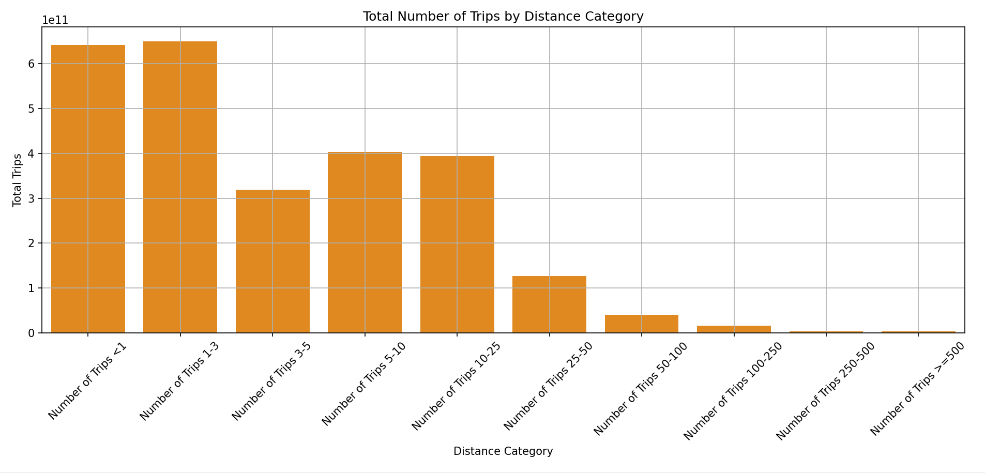

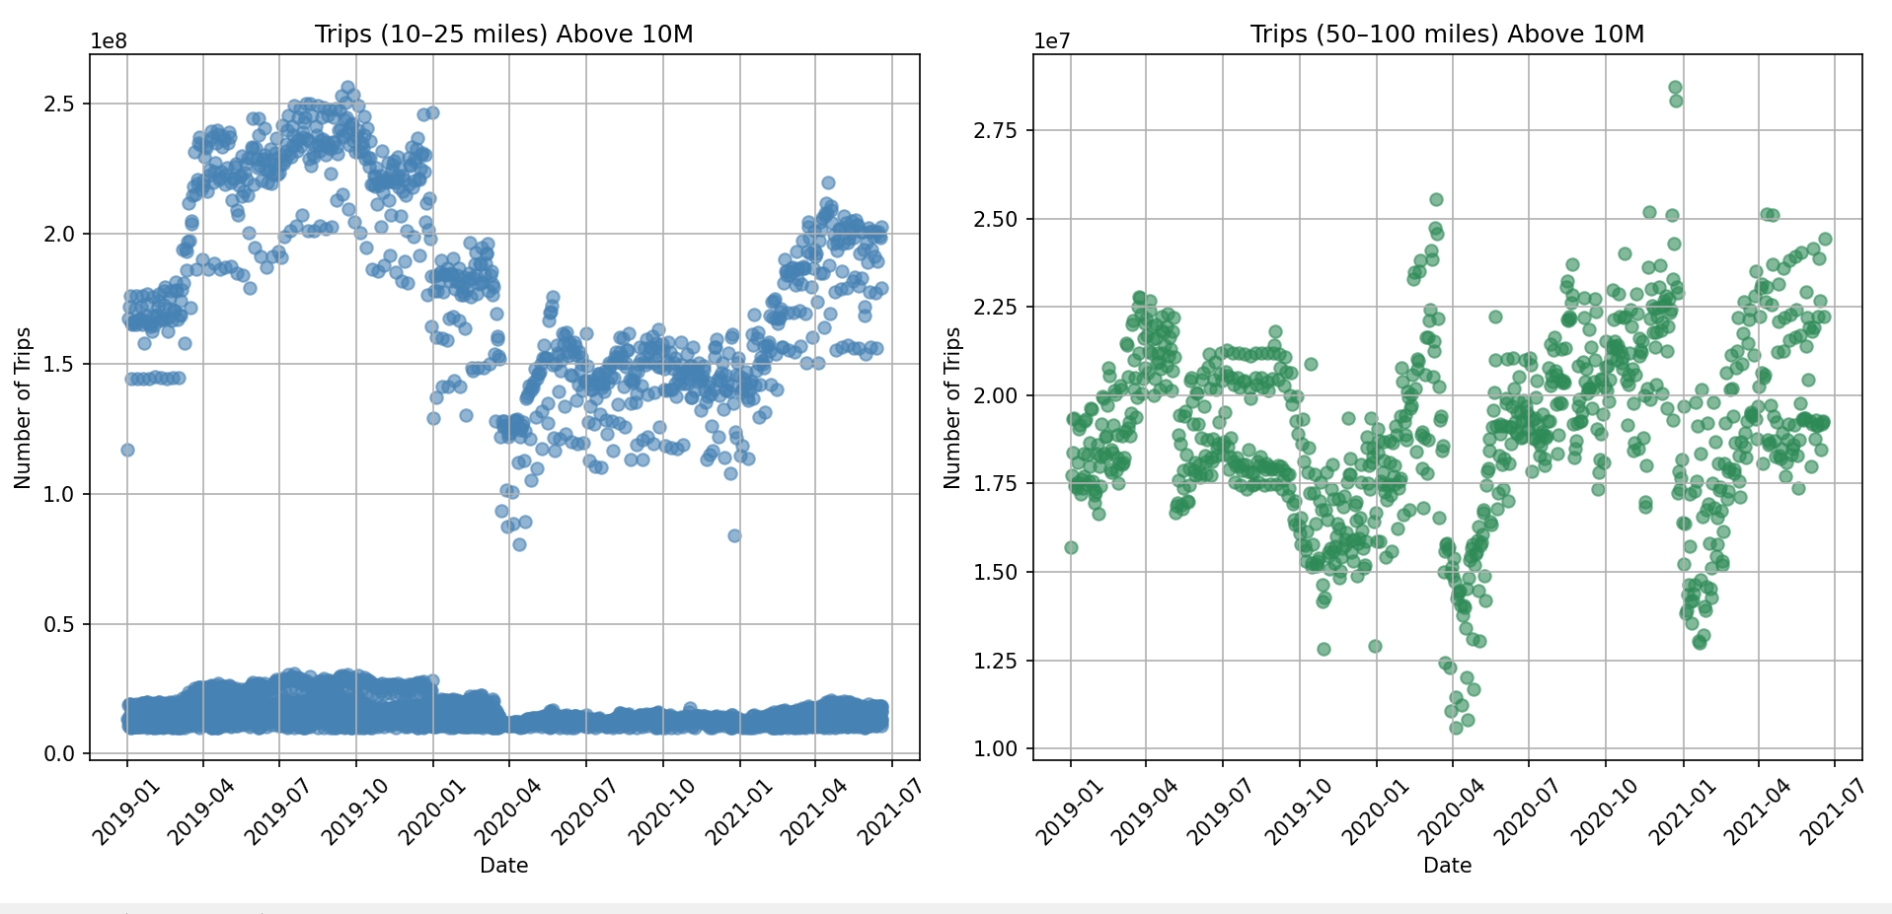

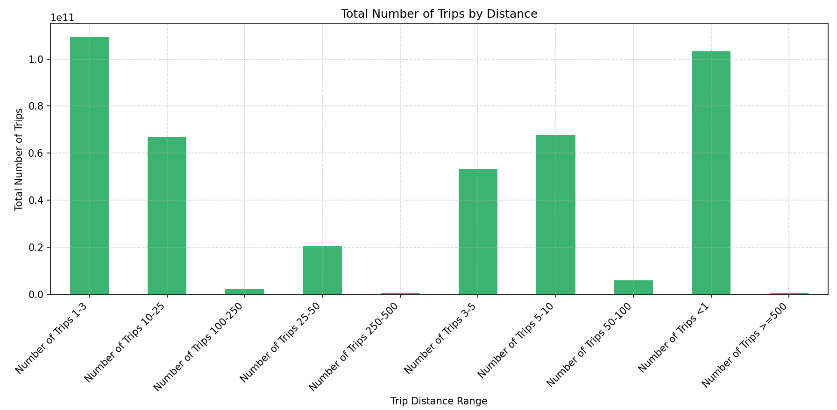

10. Data Cleaning
A process was implemented to identify and fix both absent and repeated data values in the tables. When possible the researchers converted selected columns to int64 data type.data = data.drop_duplicates()
data = data.astype({'Trips 1-25 Miles': 'int64'})

11. Data Categorization
The research evaluated distances covered in three categories: short travel distances (1–25 miles), medium distances (25–100) and long routes exceeding 100 miles. The time-series research required splitting the data by weeks for increased temporal examination..
week_32_data = data[data['Week'] == 32]

12. Parallel Computing
Performance was tested with Dask using different numbers of partitions:
import time
start = time.time()
data.compute()
print("Time taken:", time.time() - start)
Speed improved with higher partition counts, but overhead limited performance on smaller datasets.

13. Data Processing
Pandas was used for quick analysis on small chunks. For full data, Dask handled large partitions efficiently.

14. Model Selection
Models applied:
- Linear Regression for initial relationship detection.
- Polynomial Regression for non-linear patterns.
- OLS Regression for statistical diagnostics.
from sklearn.linear_model import LinearRegression
model = LinearRegression()
model.fit(X_train, y_train)

15. Data Analysis
Week 32 analysis revealed peaks in short-distance travel. Visuals confirmed trip counts over 10 million for 10–25 miles and 50–100 miles on selected days.

17. Data Visualization

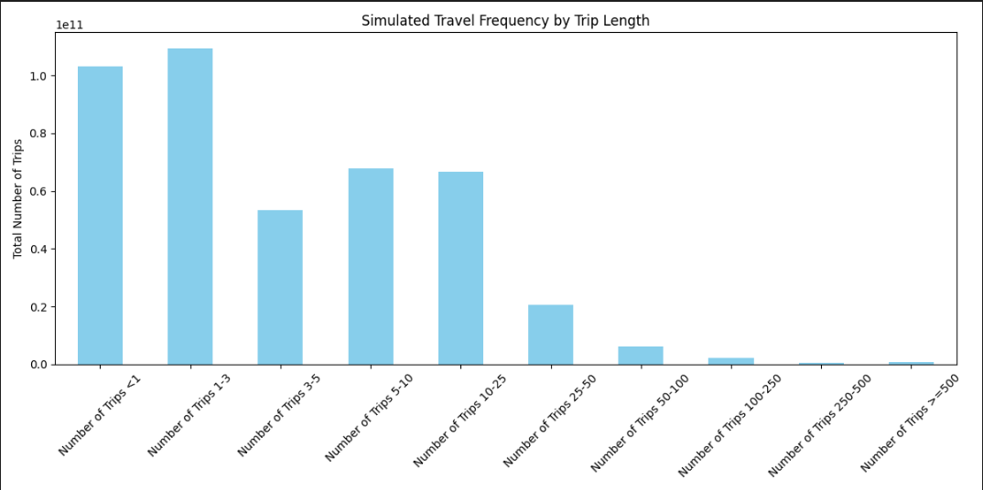

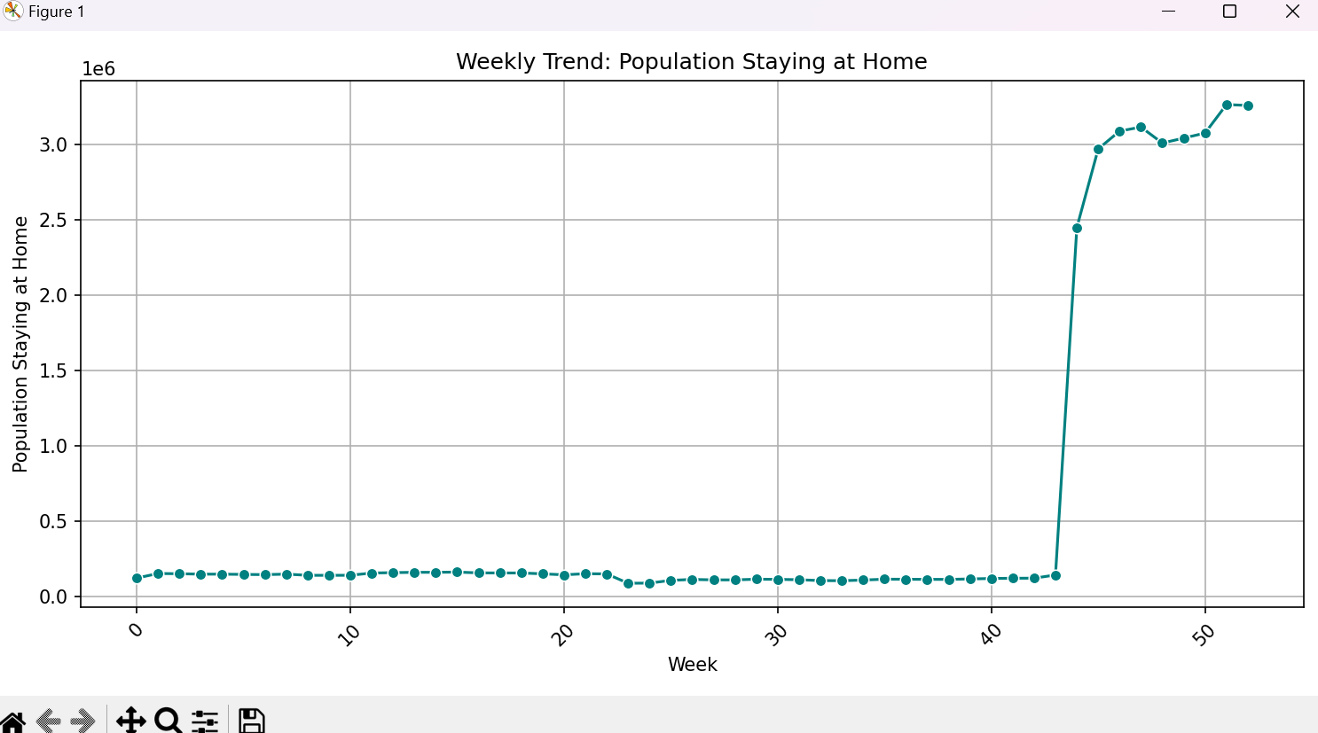

18. Results
- Short-distance trips were the most frequent.
- Parallel processing outperformed sequential methods on larger data.
- Polynomial regression best modeled trip behavior.

19. Discussion
4.1 Data Communication The research data was presented through descriptive statistics combined with bar plots and line plots and scatter plots. Visual representations smoothed the process of displaying the distribution between different distance bands as well as their temporal shifts. The bar plot that showed weekly home residence averages successfully eliminated confusion around mobility changes because it clearly demonstrated those shifts possibly stemming from policy responses or pandemic restrictions and public holidays. The use of Plotly-based interactive plots successfully showcased outlier moments when more than 10 million individuals went between 10–25 or 50–100 miles. The visual presentations consolidated massive high-volume data into simple accessible insights so essential in big data
Environments
4.2 Data Interpretation Results showed short-distance travel between 1 to 25 miles involved the most instances because individuals conduct typical daily activities such as commuting to work and shopping along with school transportation. The statistics indicate that trips exceeding 100 miles distance happen with lesser frequency because they might represent vacation journeys or business travel or relocation activities. The strong R² score of the polynomial regression model proves the relationship between distance and trip frequency to be inversely proportional. The test of executing Dask in parallel processing demonstrated its efficiency for big data handling through faster execution times than Pandas. Due to its time sensitivity transportation demands require such immediate or near-quick insights. The analysis measured and analyzed how many days produced more than 10 million trips between the 10–25 and 50–100 mile distance ranges. The analysis detected unique mid-distance travel patterns which ran independently from the short-distance peak times indicating separate reasons for each travel type.
4.3 Limitations Two important constraints exist regarding these conclusions: The data lack specific demographic information as well as location details which would enable thorough sociological breakdown to determine how urban and rural populations differ in their behaviours. The lack of classification for trip purposes including work and leisure and essential services throughout the pandemic resulted in reduced potential explanations between factors. The training happened only with Week 32 data without measuring how well this model works across weekly or geographical variations. Current data selection methods used by BTS could lead to biased results because of their mobile device criteria and filtering algorithm systems.

20. Project Management
Weekly tasks were tracked in gantts chart and flowchart (see Appendix). Tasks included data loading, modeling, visualization, and report writing.

21. Conclusion
The project managed to develop predictive models which effectively scaled up for human mobility forecast predictions. Cutting processing time proves successful and polynomial regression revealed non-linear patterns that proved effective in pattern detection. Through this method transport departments can develop their infrastructure while following policy directives.

22. References
Pedregosa, F. et al. (2012) SciKit-Learn: Machine Learning in Python, arXiv.org. Available at: https://arxiv.org/abs/1201.0490.
Dask Development Team. (2023). Dask: Library for parallel computing in Python. https://dask.org
McKinney, W. (2010). Data structures for statistical computing in Python. Proceedings of the 9th Python in Science Conference, 51–56. - Bing (no date) Bing. Available at: https://www.bing.com/search?q=McKinney%2C+W.+(2010).+Data+structures+for+statistical+computing+in+Python.+Proceedings+of+the+9th+Python+in+Science+Conference%2C+51%E2%80%9356.&cvid=9720e246756e4265bac9fcd9a4c39291&gs_lcrp=EgRlZGdlKgYIABBFGDkyBggAEEUYOdIBCDExMDJqMGo0qAIIsAIB&FORM=ANAB01&PC=LCTS.

23. Appendices A.2 Flowchart Depicts steps: 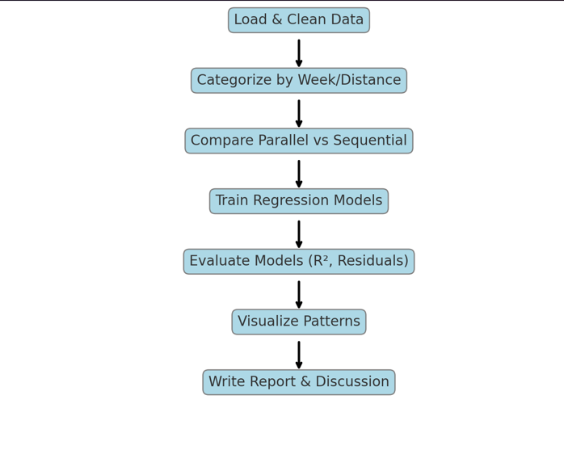
Data loading > Cleaning > Modelling > Visualization > Reporting.
A.4 Gantt Chart
Task | Start Date | End Date
Topic Selection | 01 March 2025 | 03 March 2025
Data Acquisition | 04 March 2025 | 06 March 2025
Data Cleaning | 07 March 2025 | 09 March 2025
Data Categorization | 10 March 2025 | 12 March 2025
Parallel vs Sequential | 13 March 2025 | 15 March 2025
Model Building | 16 March 2025 | 20 March 2025
Model Evaluation | 21 March 2025 | 24 March 2025
Visualization & Results | 25 March 2025 | 28 March 2025
Report Writing | 29 March 2025 | 05 April 2025
Finalization | 06 April 2025 | 17 April 2025
.

GitHub Link: https://github.com/kayceeonuora/5004CMD.git

